News from Strunz & Farah

FOR IMMEDIATE RELEASE
Contact: Nancy S. Balik, Publicist--415-525-3753 | 760-333-9296 strunzandfarahPR@gmail.com |www.strunzandfarah.com
CD and interviews available upon request

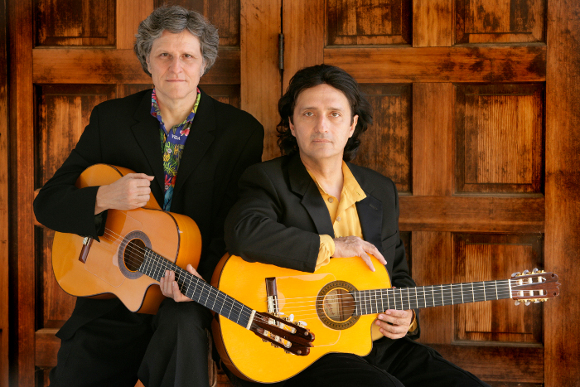 www.strunzandfarah.com

GRAMMY-NOMINATED WORLD-JAZZ GUITARISTS
STRUNZ & FARAH MARK 35 YEARS OF COLLABORATION WITH THEIR 20TH RELEASE, “MOODS & VISIONS” AND NATIONAL TOUR

Globally acclaimed acoustic guitar virtuosos feature all new original compositions on forthcoming CD and performances on both US coasts

(San Francisco, CA, April 9, 2014)--Hailed by Guitar Player as “two of the planet's most gifted acoustic guitarists,” the pioneering duo of Jorge Strunz & Ardeshir Farah announce the release of their 20th CD and 15th studio recording, “Moods and Visions” (Selva) along with an upcoming performance series in celebration of 35 years of their highly successful collaboration.

The forthcoming “Moods & Visions” represents a culmination of the duo’s ever-evolving artistry and musical exploration, rich with spellbinding improvisations and colorful sonic weavings. Nine original compositions comprise the recording, which showcases their signature guitar wizardry and mesmerizing mosaic of styles, accompanied by a superb ensemble of rhythm section and flute.

About Strunz & Farah
According to Jazziz, Strunz & Farah distinguish themselves by “bridging cultures and stunning audiences...fiery improvisations over pulse-quickening tempos...they offer a fusion of influences that perhaps no other ensemble can boast."

Revered by guitar aficionados around the world for their “dazzling virtuosity and a cross-cultural repertoire fused with Latin, (Middle Eastern), European, Afro-Cuban and American styles” (Washington Post), Strunz & Farah’s music reflects their diverse cultural influences and draws heavily from the jazz concept of improvisation.

Ingeniously spanning a wide range of styles and traditions stemming from their respective roots in Costa Rica and Iran, Strunz & Farah possess “keen melodic inventiveness, harmonic sensitivity and careening finger speed with a multi-ethnic, groove-conscious rhythm section, which (results) in a musical landscape redolent with tropical colors and rolling with flamenco thunderclaps." (Musician)

About their artistry, LA Weekly notes, “"Both guitarists are immensely gifted composers, with a masterful grasp of both melody and harmony, to say nothing of their phenomenal technique..." Guitar Player says that “Strunz and Farah are spectacular live” and for guitar lovers, “the experience can be downright apocalyptic."

About the Tour
The upcoming Strunz & Farah USA tour, which will delight guitar lovers of all genres, will feature new material from “Moods and Visions,” with harmonious support provided by Majeed Ghorbani (percussion) and Rob Hardt (flute) for shows on the East Coast, and Katisse Buckingham (flute) for shows on the West Coast.
The Tour includes the following venues and dates:

April 29, 2014, Howard Theatre, Washington, DC, 8:00 pm
April 30, 2014-- B.B. Kings, New York City, 8:00 pm
May 1, 2014-- Sculler’s Jazz Club, Boston, 8:00 pm and 10:00 pm
May 2, 2014, Boulton Center for the Arts, Bayshore, NY, 8:00 pm
May 8 and May 9, 2014 Catalina’s Jazz Club, Hollywood, CA, 8:30 pm
May 23, 2014, State Theatre, Modesto, CA, 8:00 pm
May 24, 2014, Tower Theatre, Fresno, CA, 7:30 pm
May 26, 2014 Yoshi’s San Francisco, 8:00 pm

For more information, visit: www.strunzandfarah.com

